Bryan Cabrera

Module 1.3 Assignment

6/1/2024

Link: <https://github.com/Bryan-Cabrera/CSD340.git>

Screenshots:

-With error

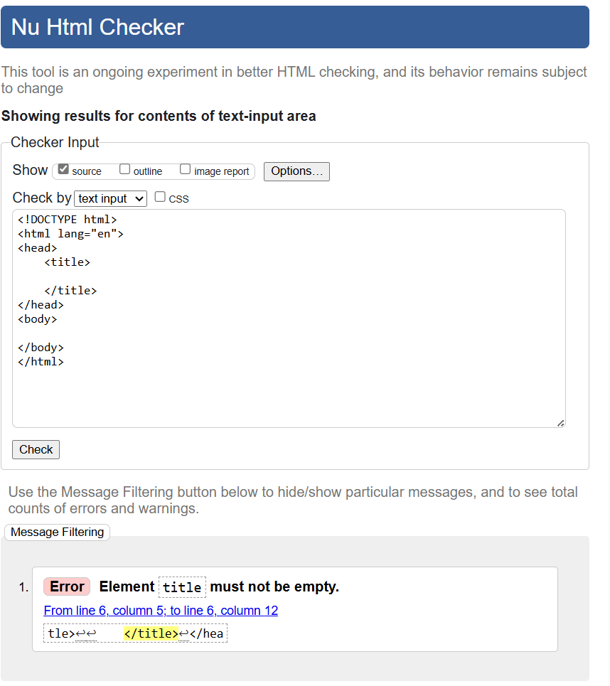

-Without error

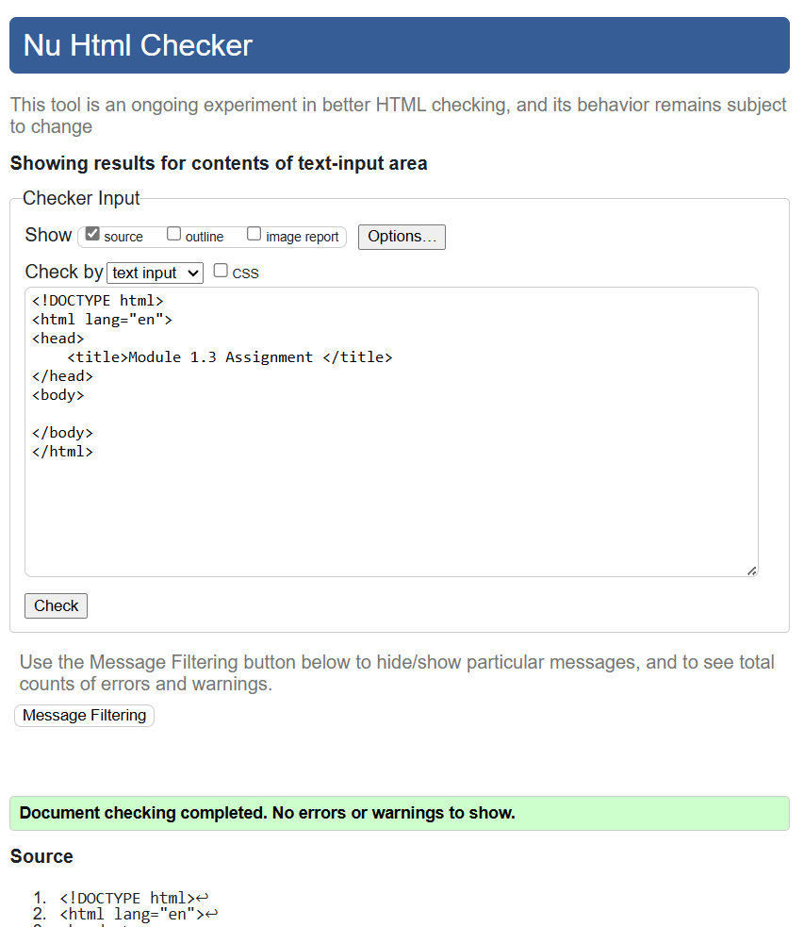

-Final check:

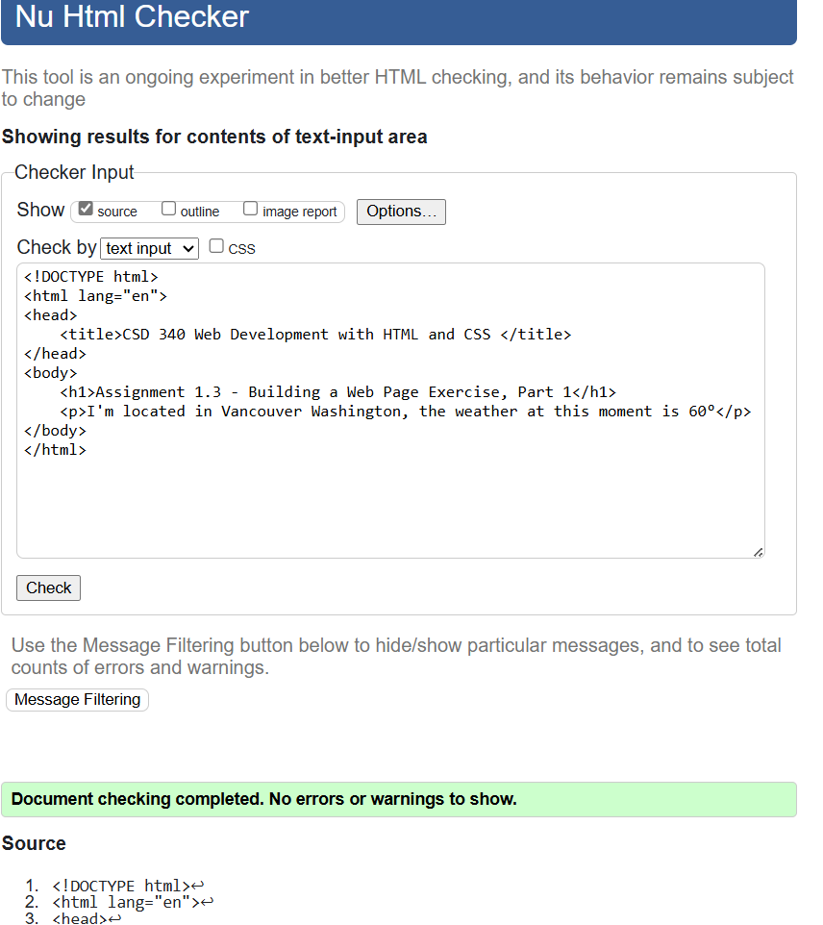

-Final Result:

